CSIT314 Software Development Methodologies - Group Project

Sprint 3 - US43: Update IDP category
Interior Design Platform - Platform Manager
All diagrams were drawn in draw.io. Open "US43 Update IDP category.drawio" in this folder to edit them - each diagram is its own page in that file. The exported images are in the "diagrams" folder.

Assumptions
- The system is the Interior Design Platform from the project specification. Sprint 3 adds the Platform Manager's stories (log out and IDP categories, US40 - US45) and the Interior Designer's first IDP story (add a current IDP, US20).
- We follow B-C-E: the actor only talks to the boundary (page), the boundary only talks to the controller, and the controller works with the entity classes. There is one controller per use case.
- Following the lecturer's feedback (the same way Sprint 1 and 2 were changed): the boundary trims and checks all the input, the controller just calls the entity and returns the result (no canXxx() access methods), the entity does the duplicate / still-Active checks, an entity object is passed around instead of a dict, and each B-C-E diagram has only one entity.
- Being logged in as a Platform Manager (UC39) is the precondition of these use cases, so the pages and the B-C-E / sequence diagrams don't check the manager again (no PlatformManagerLoginController). managerLoginRequired in app.py only sends someone with no session to /manager/login.
- The manager starts from the category details page (US42) and clicks "Update". The form is filled in with the current name and description.
- The same rules as US41 apply: name 3-50 characters and unique (ignoring capitals), description up to 500. Keeping the category's own name is allowed.
- Only the name and description change. The status is shown but can't be edited here - it is changed by US44. Updating a Suspended category keeps it Suspended.
- The IDPs in the category are not changed, so they show under the new name straight away.

1. User story
Story ID | US43
User story | As a platform manager, I want to update an IDP category so that its name and details stay up to date.
Actor | Platform Manager
Priority | Medium
Story points (estimate) | 2
Acceptance criteria | 1. Given I am on a category's details page, there is an "Update" button that opens the form filled in with the current details.  2. Given I change the name or description and click "Save changes", then the changes are saved, I go back to the details page and see "IDP category updated successfully".  3. Given the name is wrong (3-50 characters) or the description is too long, then I see "Please fix the highlighted fields" and nothing is saved.  4. Given another category already has the name, then I see "An IDP category with this name already exists" and nothing is saved.  5. Updating doesn't change the status of the category.  6. Given I click "Cancel", then I go back to the details page and nothing is saved.
Tasks | T43.1 Write the use case description and draw the use case diagram  T43.2 Draw the B-C-E class diagram and the sequence diagram  T43.3 Draw the wireframes for the Update button, the filled-in form, the name error and the success message  T43.4 Write the unit tests first (TDD) for IDPCategory.updateIDPCategory(), UpdateIDPCategoryController and the page  T43.5 Code IDPCategory.updateIDPCategory() (duplicate check in the entity, status left alone)  T43.6 Code UpdateIDPCategoryController and UpdateIDPCategoryPage  T43.7 Code the updateIDPCategory.html template  T43.8 Run the test cases, fix bugs and push to the repo so the CI pipeline runs the unit tests

2. Use case diagram
The user story becomes one use case, UC43 Update IDP category. The Platform Manager is the only actor.
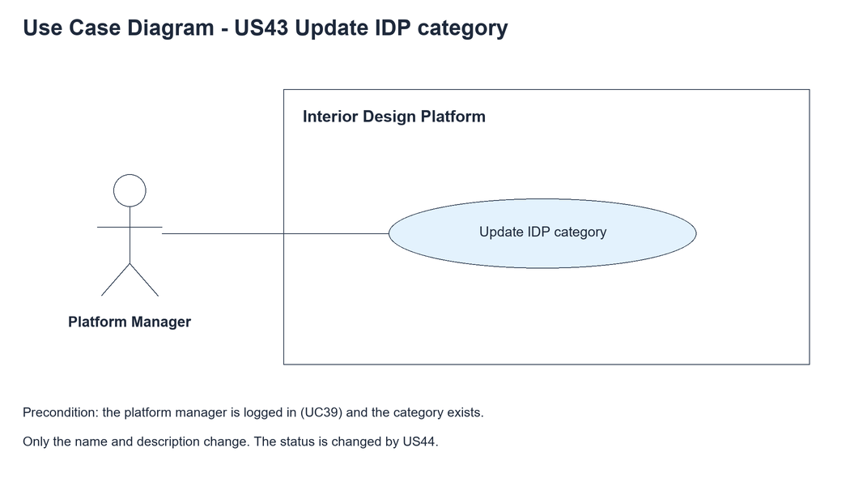
Figure 1: Use case diagram for US43 Update IDP category

3. Use case description
Use case | UC43 Update IDP category
Actor | Platform Manager
Brief description | The Platform Manager changes the name and description of an IDP category.
User story | US43: As a platform manager, I want to update an IDP category so that its name and details stay up to date.
Preconditions | The Platform Manager is logged in (UC39) and is viewing the category (UC42).
Trigger | The Platform Manager clicks "Update" on the category details page.
Basic flow | 1. The Platform Manager clicks "Update".  2. The system loads the category and shows the filled-in form.  3. The Platform Manager changes the name and/or description and clicks "Save changes".  4. The system checks the fields.  5. The system checks that no other category has the new name.  6. The system saves the new name and description. The status is not changed.  7. The system shows the details page with "IDP category updated successfully".
Alternative flows | 2a. The category doesn't exist: the system shows "IDP category not found". The use case ends.  3a. The Platform Manager clicks "Cancel": the system goes back to the details page and nothing is saved.  4a. A field is wrong: the system shows "Please fix the highlighted fields" and keeps what was typed. Back to step 3.  5a. The name is used by another category: the system shows "An IDP category with this name already exists". Back to step 3.
Postconditions | The category has the new name and description.  Its status and the IDPs in it are unchanged.

4. Wireframes
The wireframes were drawn in draw.io. They are low-fidelity: they show the layout and the flow, not the final colours. The orange numbers match the notes under each screen.

4a - Update button
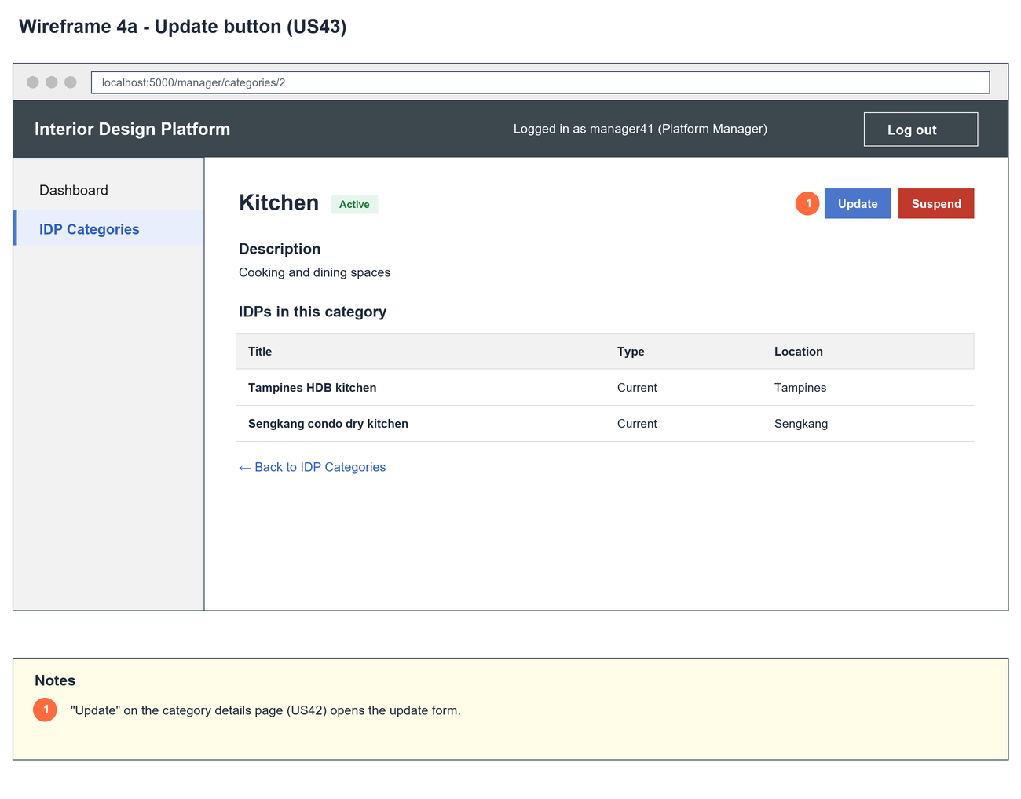
Figure 2: Wireframe 4a - Update button (US43)

4b - Update form
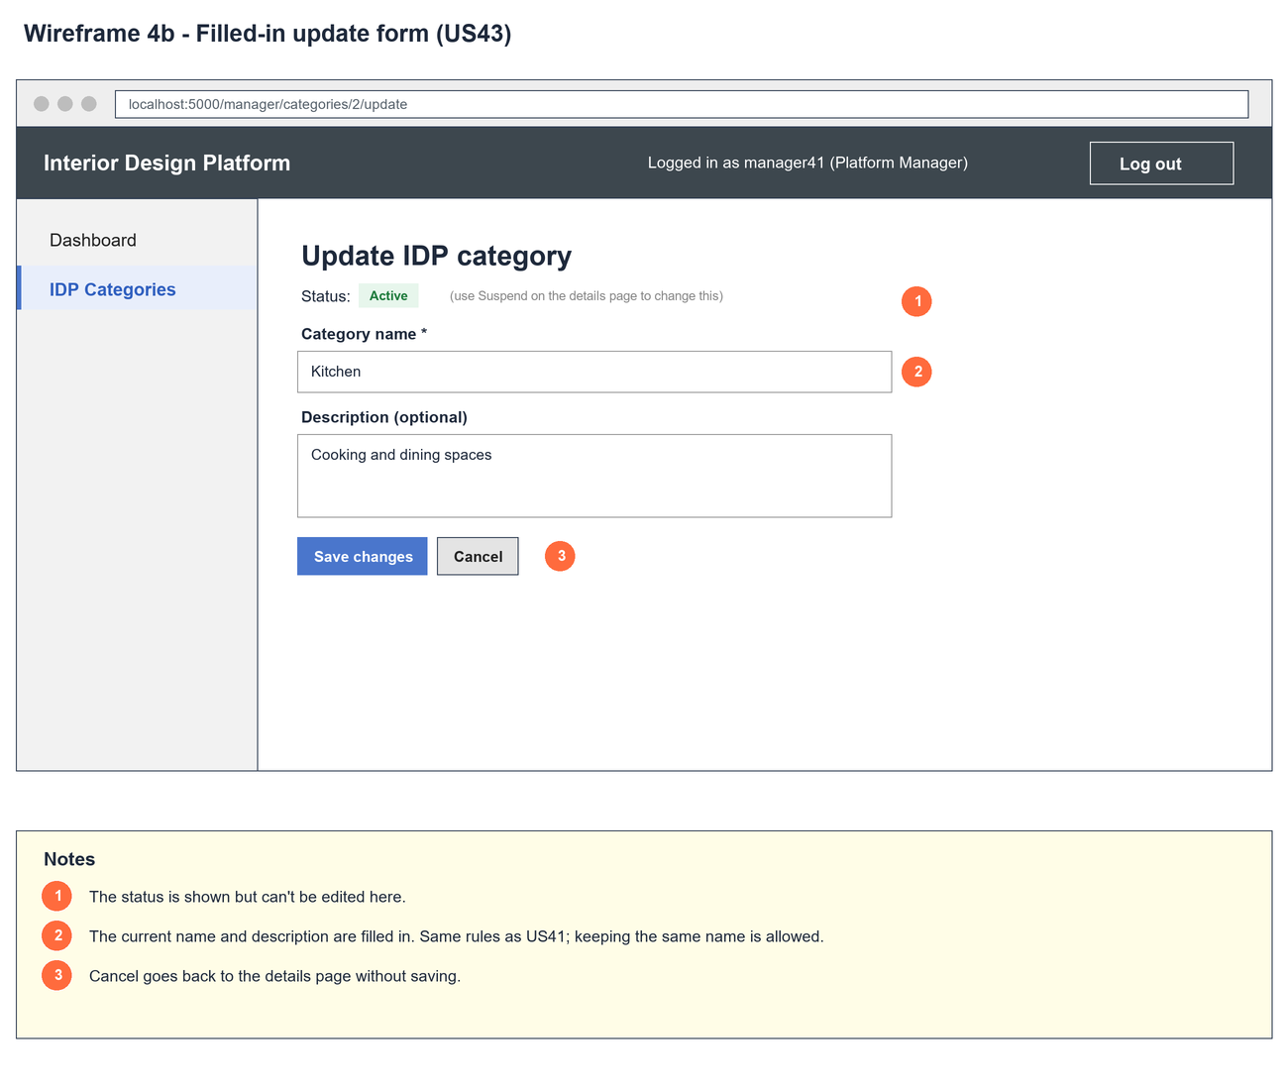
Figure 3: Wireframe 4b - Update form (US43)

4c - Name already used
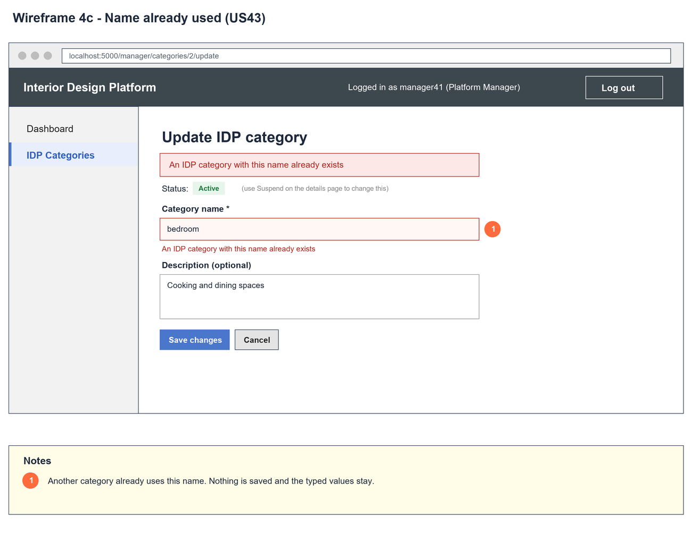
Figure 4: Wireframe 4c - Name already used (US43)

4d - Category updated
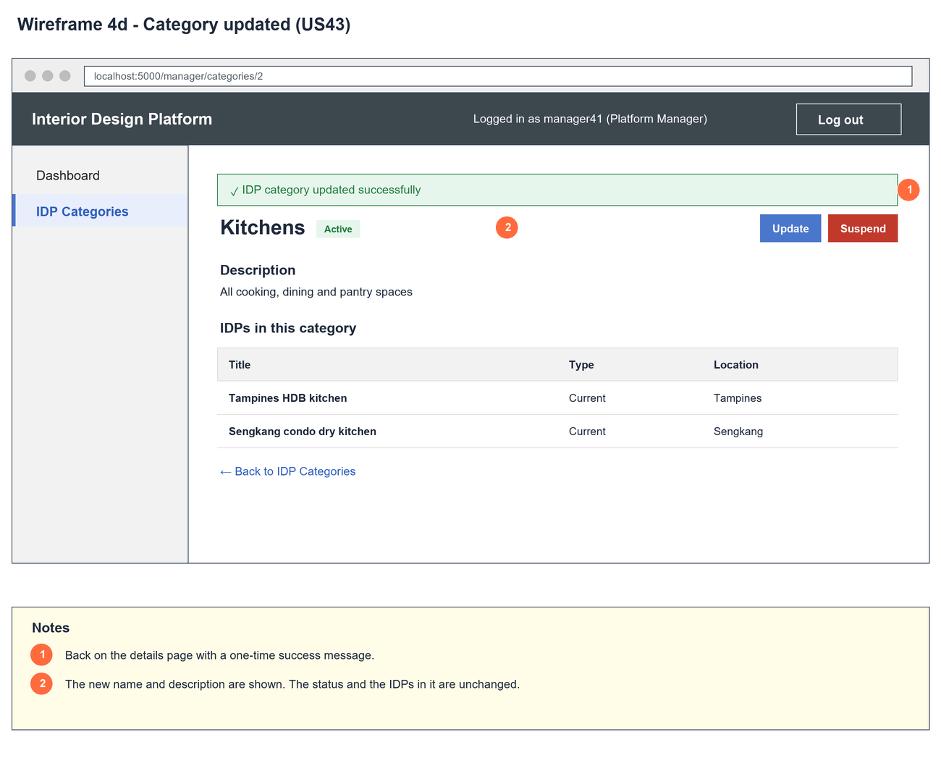
Figure 5: Wireframe 4d - Category updated (US43)

5. B-C-E class diagram
The solid line means the boundary calls the controller. The dashed lines mean the controller uses the other classes. Only the operations needed for this use case are shown, with the same names as the code.
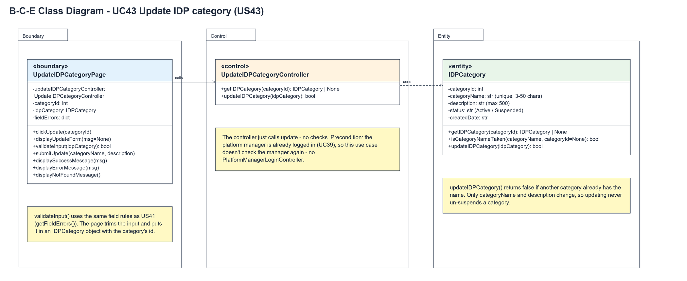
Figure 6: B-C-E class diagram for US43 Update IDP category
Layer | Class | What it does
Boundary | UpdateIDPCategoryPage | The update form. clickUpdate() loads the category into the form; submitUpdate() validates the input, asks the controller to save and shows the result. displayNotFoundMessage() handles a missing category.
Control | UpdateIDPCategoryController | Controller for UC43. getIDPCategory() loads the form and updateIDPCategory(idpCategory) saves it - both just call the entity.
Entity | IDPCategory | updateIDPCategory() checks the name with isCategoryNameTaken(name, categoryId), which ignores the category's own row, then saves the name and description only.

6. Sequence diagram
The sequence diagram follows UC43. Opening the form loads the category. On submit the page puts the input in an IDPCategory and the outer alt is valid or invalid input. When it is valid the controller just calls the entity, which checks the name isn't used by another category before saving.
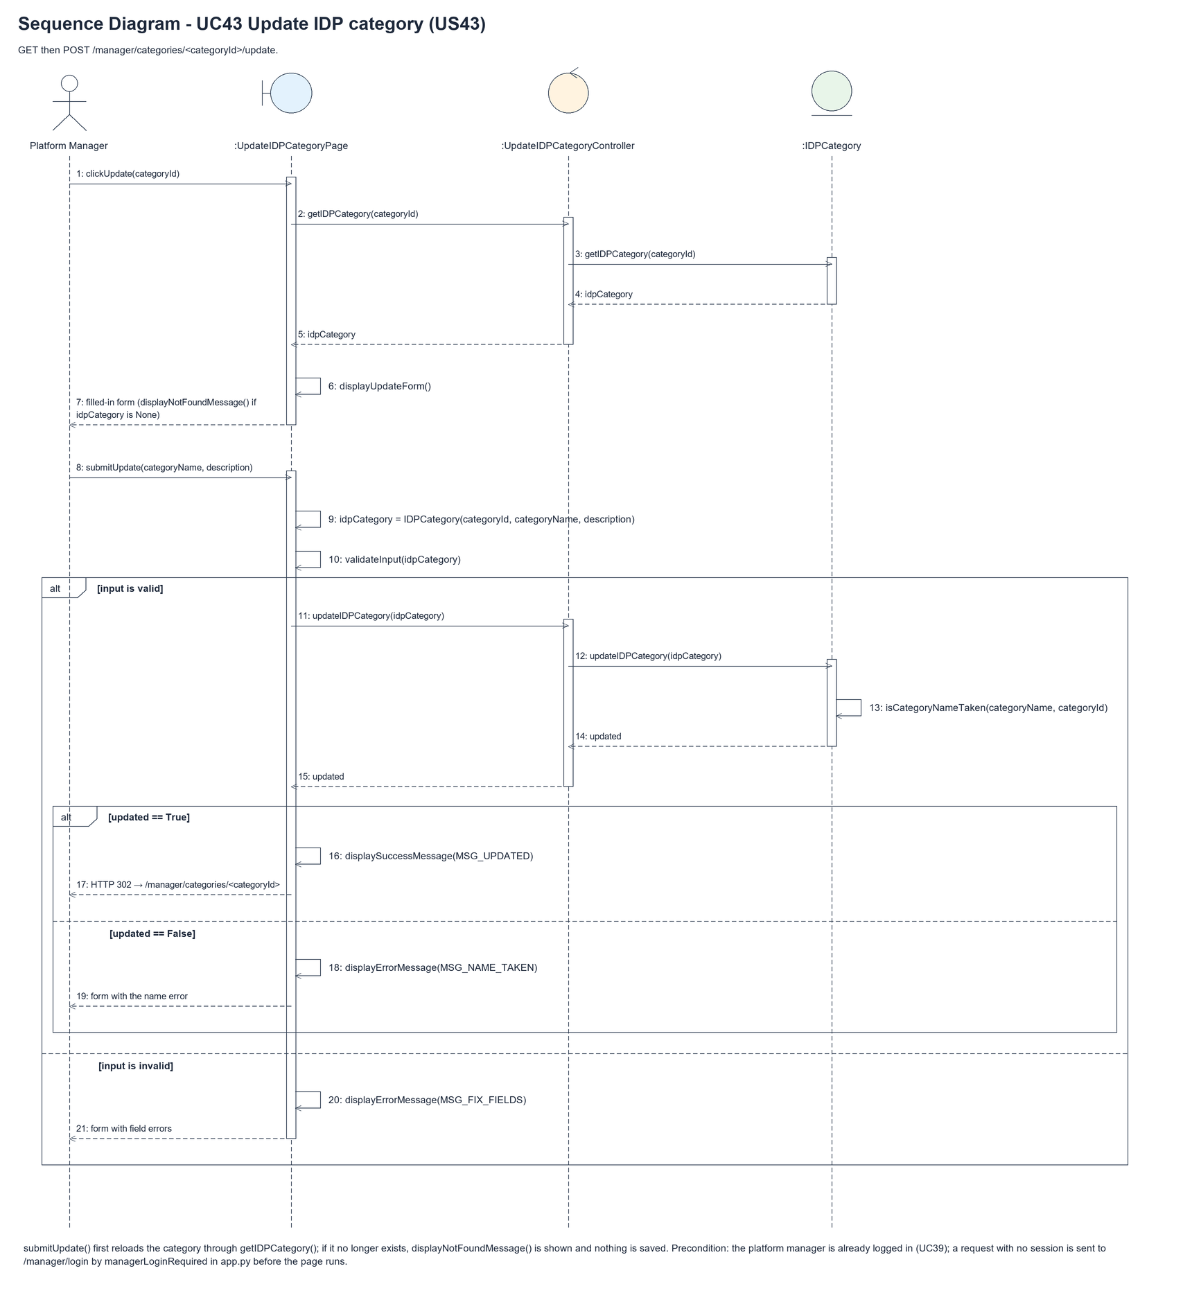
Figure 7: Sequence diagram for UC43 Update IDP category

7. Test cases
Test data used below (same as database/seedData.py and the test files): user profiles User Admin (id 1), Interior Designer (id 2), Customer (id 3) and Platform Manager (id 4), all Active. User accounts admin01 / Admin@123 (User Admin) and cust001 / Cust@123 (Customer). The manager account manager43 / Manager@123 (Daniel Tan, Platform Manager profile) is made first with UC8. IDP categories are made in each test with UC41, e.g. Kitchen ("Cooking and dining spaces"), Bedroom and Office.

7a. System test cases (black box)
Equivalence partitioning and boundary value analysis were used to pick the test data. Fill in "Actual result" and "Pass/Fail" after running each test.
Test ID | Scenario | Prerequisites | Test steps | Test data | Expected result | Actual result | Pass / Fail
TC43.1 | Update a category | Kitchen exists. | 1. View Kitchen  2. Click "Update"  3. Change the data  4. Click "Save changes" | Kitchens / All kitchens | Details page with "IDP category updated successfully" and the new name and description.
TC43.2 | Keep the same name | Kitchen exists. | 1. Change only the description  2. Save | Kitchen / New text | Saved.
TC43.3 | Name used by another category | Kitchen and Bedroom exist. | 1. Update Bedroom with the name  2. Save | kitchen | "An IDP category with this name already exists". Bedroom keeps its name.
TC43.4 | Name too short (boundary) | Kitchen exists. | 1. Enter the name  2. Save | "K" | "Please fix the highlighted fields". Nothing saved.
TC43.5 | Status not changed | Kitchen is Suspended. | 1. Update Kitchen's name  2. Save | Kitchens | Saved. The badge still says Suspended.
TC43.6 | Category not found | Logged in as manager43. | 1. Open /manager/categories/9999/update | - | "IDP category not found".
TC43.7 | Not logged in | Not logged in. | 1. Post the update form | Hacked | The manager login page is shown. The category is unchanged.

7b. Unit test cases (for TDD)
These are written before the code (test-driven development) and run with pytest. They cover normal inputs, abnormal inputs and boundary values. Each one matches a test function in tests/test_us43_updateIDPCategory.py (UT43.n = test_ut43_n_...).
Test ID | Class and method | Input / setup | Expected output | Type | Pass / Fail
UT43.1 | IDPCategory.isCategoryNameTaken() | Own name with own categoryId | Returns false | Boundary | Pass
UT43.2 | IDPCategory.isCategoryNameTaken() | "kitchen" with Bedroom's id | Returns true | Normal | Pass
UT43.3 | UpdateIDPCategoryController.updateIDPCategory() | Kitchens / New text | True. Name and description changed | Normal | Pass
UT43.4 | UpdateIDPCategoryController.updateIDPCategory() | Bedroom renamed "KITCHEN" | False. Bedroom unchanged | Abnormal | Pass
UT43.5 | UpdateIDPCategoryController.updateIDPCategory() | Id 9999 | Returns false | Abnormal | Pass
UT43.7 | UpdateIDPCategoryController.updateIDPCategory() | Same name, new description | Returns true | Boundary | Pass
UT43.8 | UpdateIDPCategoryController.updateIDPCategory() | Suspended category | True. Still Suspended | Normal | Pass
UT43.9 | UpdateIDPCategoryPage.validateInput() | Valid, "Ki", 501-char description | True, false, false | Boundary | Pass
UT43.10 | UpdateIDPCategoryPage.clickUpdate() | GET the update form | Form filled with Kitchen and its description | Normal | Pass
UT43.11 | UpdateIDPCategoryPage.submitUpdate() | Kitchens / All kitchens | Redirect to details with "IDP category updated successfully" | Normal | Pass
UT43.12 | UpdateIDPCategoryPage.submitUpdate() | "kitchen" for Bedroom | "An IDP category with this name already exists". Typed text kept | Abnormal | Pass
UT43.13 | UpdateIDPCategoryPage.submitUpdate() | Name "K" | "Please fix the highlighted fields". Unchanged | Abnormal | Pass
UT43.14 | UpdateIDPCategoryPage.displayNotFoundMessage() | GET /manager/categories/9999/update | "IDP category not found" | Abnormal | Pass
UT43.6 | UpdateIDPCategoryPage.submitUpdate() | Name of spaces only | "Category name must be 3-50 characters". Unchanged | Abnormal | Pass
UT43.15 | /manager/categories/<id>/update (managerLoginRequired) | Not logged in, POST | Redirects to /manager/login. Unchanged | Abnormal | Pass

